Rate Limiting Middleware

📝Definition
# Source: AI Source: Provided by: [Data Path: Persons Table -> ID Column: 1, Name_En Column: Motasem Essam] -> From: [ChatGPT] on [1/23/2026]
Rate Limiting Middleware controls how often clients can make requests to your server in a given time frame.
👉 It answers the question: “Are you sending too many requests too quickly?”

🔑 Key Responsibilities
# Source: AI Source: Provided by: [Data Path: Persons Table -> ID Column: 1, Name_En Column: Motasem Essam] -> From: [ChatGPT] on [1/23/2026]
- Prevent abuse or overload of your API
- Protect server from DDoS attacks
- Limit requests per user, IP, or API key
- Return proper HTTP responses when limits are exceeded

🔄 How It Works in Flow
# Source: AI Source: Provided by: [Data Path: Persons Table -> ID Column: 1, Name_En Column: Motasem Essam] -> From: [ChatGPT] on [1/23/2026]
Client → Request → Rate Limiting Middleware → Controller → Response
- Middleware counts requests from each client
- If the client exceeds the limit → return 429 Too Many Requests
- Otherwise → request proceeds ✅

🧱 Examples

1️⃣ Laravel Built-in Rate Limiting
# Source: AI Source: Provided by: [Data Path: Persons Table -> ID Column: 1, Name_En Column: Motasem Essam] -> From: [ChatGPT] on [1/23/2026]
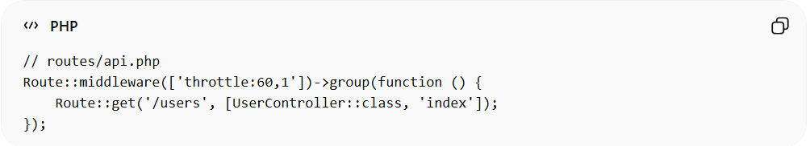
// routes/api.php
Route::middleware(['throttle:60,1'])->group(function () {
Route::get('/users', [UserController::class, 'index']);
});
- throttle:60,1 → 60 requests per 1 minute
- Middleware automatically returns 429 when exceeded

2️⃣ Custom Rate Limiting Middleware
# Source: AI Source: Provided by: [Data Path: Persons Table -> ID Column: 1, Name_En Column: Motasem Essam] -> From: [ChatGPT] on [1/23/2026]
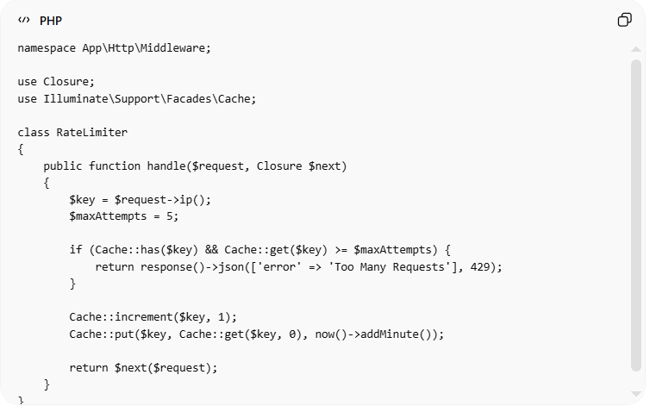
namespace App\Http\Middleware;

use Closure;
use Illuminate\Support\Facades\Cache;

class RateLimiter
{
public function handle($request, Closure $next)
{
$key = $request->ip();
$maxAttempts = 5;

if (Cache::has($key) && Cache::get($key) >= $maxAttempts) {
return response()->json(['error' => 'Too Many Requests'], 429);
}

Cache::increment($key, 1);
Cache::put($key, Cache::get($key, 0), now()->addMinute());

return $next($request);
}
}

❌ Bad Example (No Rate Limiting)
# Source: AI Source: Provided by: [Data Path: Persons Table -> ID Column: 1, Name_En Column: Motasem Essam] -> From: [ChatGPT] on [1/23/2026]

Route::get('/api/login', [AuthController::class, 'login']);
Problems:
- Anyone can spam login attempts ❌
- High risk of DDoS or brute-force attacks ❌

✅ Good Example (With Rate Limiting)
# Source: AI Source: Provided by: [Data Path: Persons Table -> ID Column: 1, Name_En Column: Motasem Essam] -> From: [ChatGPT] on [1/23/2026]
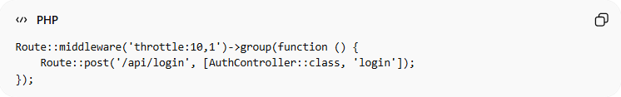
Route::middleware('throttle:10,1')->group(function () {
Route::post('/api/login', [AuthController::class, 'login']);
});
- Limits 10 login attempts per minute ✅
- Protects server and users ✅
- Centralized and reusable ✅

🔄 Relation to Other Middleware
# Source: AI Source: Provided by: [Data Path: Persons Table -> ID Column: 1, Name_En Column: Motasem Essam] -> From: [ChatGPT] on [1/23/2026]
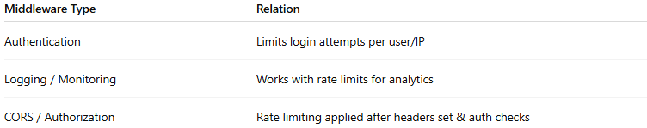
Middleware Type | Relation
Authentication | Limits login attempts per user/IP
Logging / Monitoring | Works with rate limits for analytics
CORS / Authorization | Rate limiting applied after headers set & auth checks

⚠️ Common Mistakes
# Source: AI Source: Provided by: [Data Path: Persons Table -> ID Column: 1, Name_En Column: Motasem Essam] -> From: [ChatGPT] on [1/23/2026]
- Not applying rate limits to critical endpoints ❌
- Allowing unlimited requests in production ❌
- Hardcoding limits in controller instead of middleware ❌

💡 Key Idea
# Source: AI Source: Provided by: [Data Path: Persons Table -> ID Column: 1, Name_En Column: Motasem Essam] -> From: [ChatGPT] on [1/23/2026]
Rate Limiting Middleware protects your API and server from overload and abuse, improving stability and security.

🧾 Summary
# Source: AI Source: Provided by: [Data Path: Persons Table -> ID Column: 1, Name_En Column: Motasem Essam] -> From: [ChatGPT] on [1/23/2026]
- Controls request frequency per client
- Returns 429 Too Many Requests if limit exceeded
- Keeps server stable and secure
- Easy to centralize and reuse

